Obstacle avoidance module

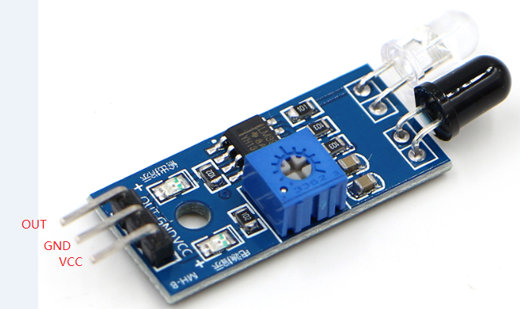

Obstacle avoidance module arduinocontroller

OUT 3

GND GND

VCC VCC